**EXPERIMENT-5**

**Student Name:** Piyush Prashar **UID:**22BET10096

**Branch:** BE -IT **Section/Group:**22BET_IOT-703(A)

**Semester:** 6th **Subject Code:** 22ITP-351

**PROBLEM-1**

**AIM:-**

[Longest Increasing Subsequence](https://leetcode.com/problems/longest-nice-substring/)

**CODE:-**

class Solution {

    public int lengthOfLIS(int[] nums) {

        List<Integer> res = new ArrayList<>();

        for (int n : nums) {

            if (res.isEmpty() || res.get(res.size() - 1) < n) {

                res.add(n);

            } else {

                int idx = binarySearch(res, n);

                res.set(idx, n);

            }

        }

        return res.size();

    }

    private int binarySearch(List<Integer> arr, int target) {

        int left = 0;

        int right = arr.size() - 1;

        while (left <= right) {

            int mid = (left + right) / 2;

            if (arr.get(mid) == target) {

                return mid;

            } else if (arr.get(mid) > target) {

                right = mid - 1;

            } else {

                left = mid + 1;

            }

        }

        return left;

    }

}

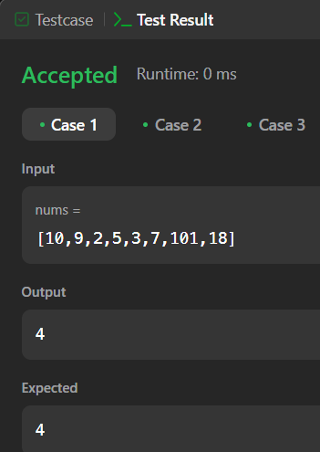 **OUTPUT:-** 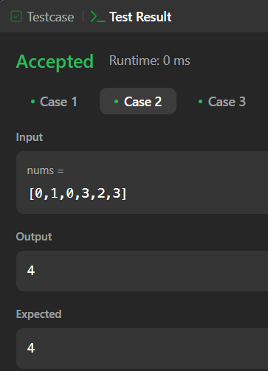

**PROBLEM-2**

**AIM:-**

Maximum Product Subarray

**CODE:**-

class Solution {

    public int maxProduct(int[] nums) {

        int res = Integer.MIN_VALUE;

        for (int n : nums) {

            res = Math.max(res, n);

        }

        int curMax = 1, curMin = 1;

        for (int n : nums) {

            int temp = curMax * n;

            curMax = Math.max(temp, Math.max(curMin * n, n));

            curMin = Math.min(temp, Math.min(curMin * n, n));

            res = Math.max(res, curMax);

        }

        return res;

    }

}

**OUTPUT:-**

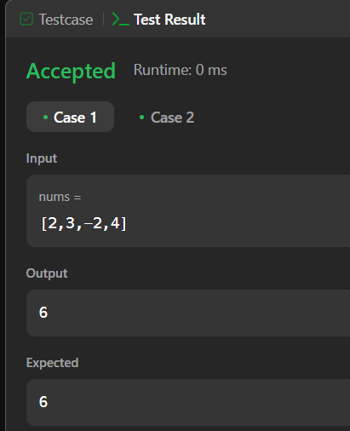

**PROBLEM-3**

**AIM:-**

Decode Ways

**CODE:-**

class Solution {

    public int numDecodings(String s) {

        if (s.charAt(0) == '0') {

            return 0;

        }

        int n = s.length();

        int[] dp = new int[n + 1];

        dp[0] = dp[1] = 1;

        for (int i = 2; i <= n; i++) {

            int one = Character.getNumericValue(s.charAt(i - 1));

            int two = Integer.parseInt(s.substring(i - 2, i));

            if (1 <= one && one <= 9) {

                dp[i] += dp[i - 1];

            }

            if (10 <= two && two <= 26) {

                dp[i] += dp[i - 2];

            }

        }

        return dp[n];

    }

}

**OUTPUT:-**

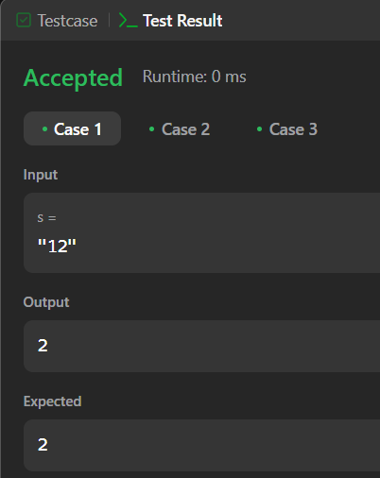

**PROBLEM-4**

**AIM:-**

Coin Change

**CODE:-**

class Solution {

public int coinChange(int[] coins, int amount) {

int[] minCoins = new int[amount + 1];

Arrays.fill(minCoins, amount + 1);

minCoins[0] = 0;

for (int i = 1; i <= amount; i++) {

for (int j = 0; j < coins.length; j++) {

if (i - coins[j] >= 0) {

minCoins[i] = Math.min(minCoins[i], 1 + minCoins[i - coins[j]]);

}

}

}

return minCoins[amount] != amount + 1 ? minCoins[amount] : -1;

}

} **OUTPUT:-**

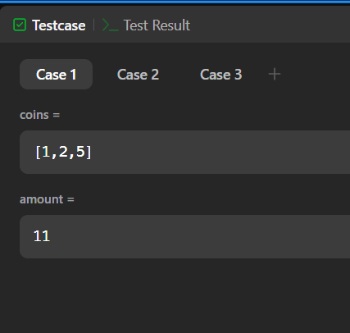

**PROBLEM-5**

**AIM:-**

Perfect Squares

**CODE:-**

public class Solution {

    public boolean searchMatrix(int[][] matrix, int target) {

        if(matrix == null || matrix.length < 1 || matrix[0].length <1) {

            return false;

        }

        int col = matrix[0].length-1;

        int row = 0;

        while(col >= 0 && row <= matrix.length-1) {

            if(target == matrix[row][col]) {

                return true;

            } else if(target < matrix[row][col]) {

                col--;

            } else if(target > matrix[row][col]) {

                row++;

            }

        }

        return false;

    }

}

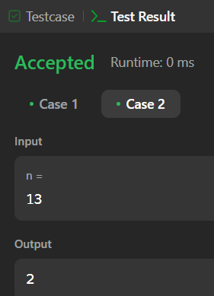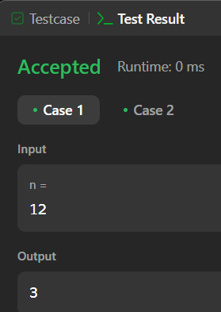

**PROBLEM-6**

**AIM:-**

Word Break

**CODE:-**

**OUTPUT:-**

class Solution {

public boolean wordBreak(String s, List<String> wordDict) {

return recWay1(s, wordDict);

}

boolean recWay2(String s, List<String> wordDict) {

Boolean[] memo = new Boolean[s.length() + 1];

return wordBreak2(s, new HashSet<>(wordDict), 0, memo);

}

boolean wordBreak2(String s, Set<String> wordDict, int k, Boolean[] memo) {

int n = s.length();

if (k == n) return true;

if (memo[k] != null) return memo[k];

for (int i=k + 1; i<=n; i++) {

String word = s.substring(k, i);

if (wordDict.contains(word) && wordBreak2(s, wordDict, i, memo)) {

return memo[k] = true;

}

}

return memo[k] = false;

}

boolean recWay1(String s, List<String> wordDict) {

Boolean[] memo = new Boolean[s.length() + 1];

return wordBreak(s, wordDict, 0, memo);

}

boolean wordBreak(String s, List<String> wordDict, int k, Boolean[] memo) {

if (k == s.length()) {

return true;

}

if (memo[k] != null) {

return memo[k];

}

for (int i=0; i<wordDict.size(); i++) {

String word = wordDict.get(i);

if (s.startsWith(word, k)) {

if(wordBreak(s, wordDict, k + word.length(), memo)) return memo[k] = true;

}

}

return memo[k] = false;

}

}

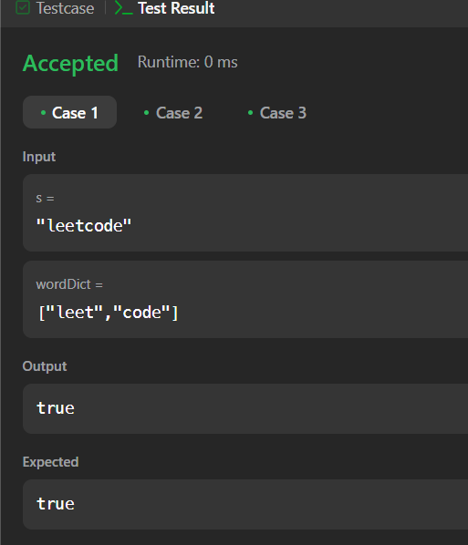

**PROBLEM-7**

**AIM:-**

Word Break 2

**CODE:-**

import java.util.*;

class Solution {

public List<String> wordBreak(String s, List<String> wordDict) {

Set<String> wordSet = new HashSet<>(wordDict);

Map<Integer, List<String>> memo = new HashMap<>();

return backtrack(s, 0, wordSet, memo);

}

private List<String> backtrack(String s, int start, Set<String> wordSet, Map<Integer, List<String>> memo) {

if (memo.containsKey(start)) {

return memo.get(start);

}

List<String> result = new ArrayList<>();

if (start == s.length()) {

result.add("");

return result;

}

for (int end = start + 1; end <= s.length(); end++) {

String word = s.substring(start, end);

if (wordSet.contains(word)) {

List<String> sublist = backtrack(s, end, wordSet, memo);

for (String sub : sublist) {

if (sub.isEmpty()) {

result.add(word);

} else {

result.add(word + " " + sub);

}

}

}

}

memo.put(start, result);

return result;

}

}

